In an experiment to find the relationship between a student’s BMI and his t-shirt size, the following data were collected:

|  |  |  |  |
| --- | --- | --- | --- |
| Name | Height(cm) | Weight(kg) | Size |
| Sharon | 172 | 59.5 | M |
| Mic | 166 | 65.6 | L |
| Josh | 187 | 49.8 | S |
| Hannah | 200 | 64.2 | M |
| Hanzel | 166 | 47.5 | S |
|  |  |  |  |

(Assume that only 3 sizes: S, M and L are being considered)

1. Using Python, create 4 lists (name_list, height_list, weight_list, size_list) to store the data given in the table, one list for each column.

Create another new list (bmi_list), to calculate and store the student’s corresponding BMI.

(The formula for calculating BMI is weight/(height/100)2)

Print a table using the 5 lists, to present the data as follows:

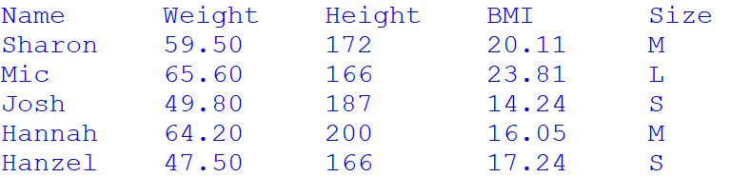

(8 marks)

1. It is proposed that the following guideline be used to predict a student’s t-shirt size based on his BMI:

|  |  |
| --- | --- |
| bmi | size |
| Less than or equal to 18 | S |
| Between 18 and 21 inclusive | M |
| More than 21 | L |

Create a list (predicted_list), to predict based on the above guideline and store the student’s t-shirt size.

Print a table using the lists created in part 3(a) and part 3(b) , followed by the accuracy rate of the prediction, which is the percentage of correct predictions, in 2 decimal places.

You do not need to include the code for creation of lists in part 3(a). BMI should not be re-calculated again.

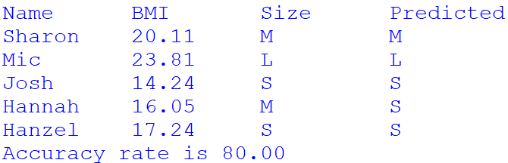

(12 marks)

1. Assuming that a nested list, containing the following information (name, gender, age) was given.

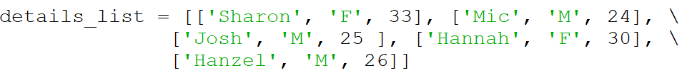

Given weight, height, gender and age, the BMR (Basal Metabolic Rate) of a student can be calculated:

BMR for Men = 66.47 + (13.7 * weight) + (5 * height) − (6.8 * age)

BMR for Women = 655.1 + (9.6 * weight) + (1.8 * height) − (4.7 * age)

Print a table using the lists created in QUESTION part 3(a) and the details_list to present the following information. You do not need to include the code for creation of lists in part 3(a).

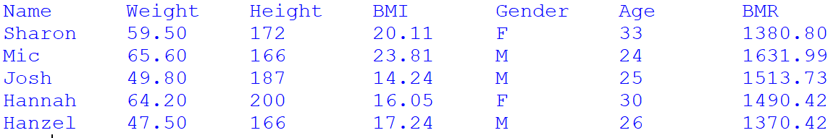

(10 marks)